LEON ERROL PARTIAL FILMOGRAPHY
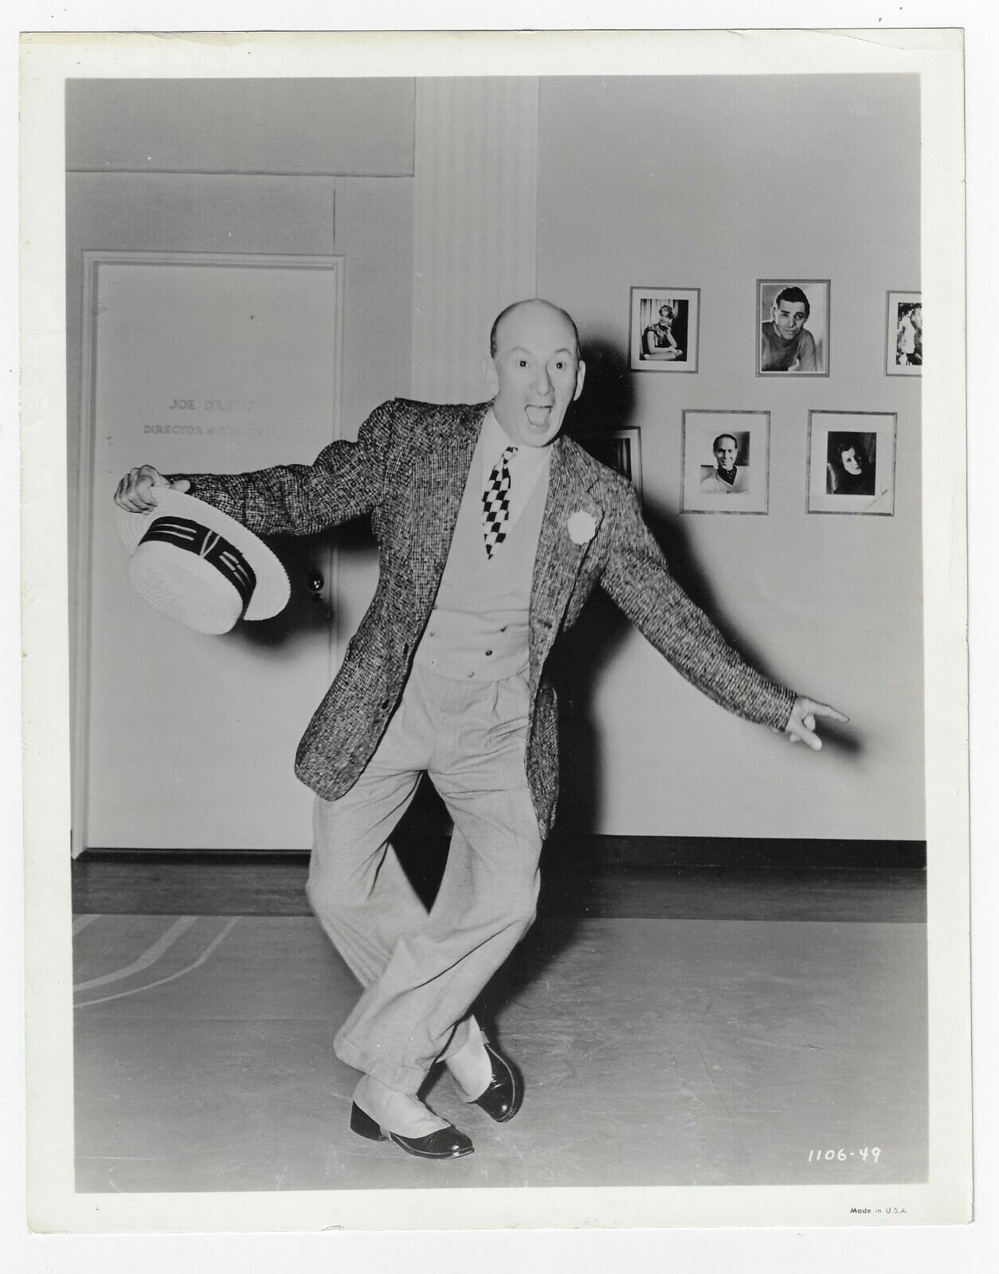
Yolanda (1924) - Innkeeper
Sally (1925) - Duke of Checkergovinia
Clothes Make the Pirate (1925) - Tremble-at-Evil Tidd
The Lunatic at Large (1927) - Sam Smith
Paramount on Parade (1930) - Leon Errol / Master of Ceremonies / (In a Hospital)
Only Saps Work (1930) - James Wilson
One Heavenly Night (1931) - Otto
Finn and Hattie (1931) - Finley P. Haddock
Her Majesty, Love (1931) - Baron von Schwarzdorf
Alice in Wonderland (1933) - Uncle Gilbert
We're Not Dressing (1934) - Hubert
The Notorious Sophie Lang (1934) - Stubbs
Service with a Smile (1934) - Walter Webb (Technicolor short subject)
Good Morning, Eve! (1934) - Adam (Technicolor short subject)
The Captain Hates the Sea (1934) - Layton
Princess O'Hara (1935) - Last Card Louie
Coronado (1935) - Otto Wray
Should Wives Work? (1937) - Brennan
The Girl from Mexico (1939) - Uncle Matthew "Matt" Lindsay (first of the Mexican Spitfire series)
Career (1939) - Mudcat
Dancing Co-Ed (1939) - 'Pops' Marlow
Mexican Spitfire (1940) - Uncle Matt Lindsay / Lord Basil Epping
Pop Always Pays (1940) - Henry Brewster
The Golden Fleecing (1940) - Uncle Waldo Blake
Mexican Spitfire Out West (1940) - Uncle Matt Lindsay / Lord Basil Epping
Where Did You Get That Girl? (1941) - Alex MacDevin
Six Lessons from Madame La Zonga (1941) - Mike Clancy / Papa Alvarez
Hurry, Charlie, Hurry (1941) - Daniel Jennings Boone
Moonlight in Hawaii (1941) - Walter Spencer
Never Give a Sucker an Even Break (1941) - Leon, W. C. Fields's rival
The Mexican Spitfire's Baby (1941) - Uncle Matt Lindsay / Lord Basil Epping
Melody Lane (1941) - McKenzie
Mexican Spitfire at Sea (1942) - Uncle Matt Lindsay / Lord Basil Epping
Mexican Spitfire's Elephant (1942) - Uncle Matt Lindsay / Lord Basil Epping
Strictly in the Groove (1942) - Carter B. Durham
Follow the Band (1943) - Big Mike O'Brien
Cowboy in Manhattan (1943) - Hank
Gals, Incorporated (1943) - Cornelius Rensington III
Mexican Spitfire's Blessed Event (1943) - Uncle Matt Lindsay / Lord Basil Epping
Higher and Higher (1943) - Cyrus Drake
Hat Check Honey (1944) - 'Happy' Dan Briggs
Slightly Terrific (1944) - James P. Tuttle / John P. Tuttle
Twilight on the Prairie (1944) - Cactus (ranch foreman)
The Invisible Man's Revenge (1944) - Herbert
Babes on Swing Street (1944) - Malcolm Curtis
She Gets Her Man (1945) - Officer Mulligan
Under Western Skies (1945) - Willie Wells
What a Blonde (1945) - F. Farrington Fowler
Mama Loves Papa (1945) - Wilbur Todd
Riverboat Rhythm (1946) - Matt Lindsay
Joe Palooka, Champ (1946) - Knobby Walsh
Gentleman Joe Palooka (1946) - Knobby Walsh
Joe Palooka in the Knockout (1947) - Knobby Walsh
Joe Palooka in Fighting Mad (1948) - Knobby Walsh
The Noose Hangs High (1948) - Julius Caesar 'J.C.' McBride
Joe Palooka in the Big Fight (1949) - Knobby Walsh
Joe Palooka in the Counterpunch (1949) - Knobby Walsh
Joe Palooka Meets Humphrey (1950) - Knobby Walsh / Lord Cecil Poole
Joe Palooka in Humphrey Takes a Chance (1950) - Knobby Walsh

